Assignment -3
Name: Bhavin Patil
Roll No.: 66
Class: TY CS-D

Assignment based on Josephus Problem using Circular Linked List and Recursive approach.
- Circular Linked List
Code:
#include <bits/stdc++.h>
using namespace std;

struct Node
{
int player_id;
struct Node *next;
};

struct Node *start;
struct Node *ptr;
struct Node *new_node;

int main()
{
cout << "Enter the number of people: " << endl;
int n;
cin >> n;
cout << "Enter the value of K: " << endl;
int k;
cin >> k;
start = new Node;
start->player_id = 1;
ptr = start;
for (int i = 2; i <= 5; i++)
{
new_node = new Node;
ptr->next = new_node;
new_node->player_id = i;
new_node->next = start;
ptr = new_node;
}

for (int i = n; i > 1; i--)
{
for (int j = 0; j < k - 1; j++)
ptr = ptr->next;

cout << ptr->next->player_id << " Executed !" << endl;
ptr->next = ptr->next->next;
}

cout << "The Winner is Player " << ptr->player_id << endl;
return 0;
}

Output:
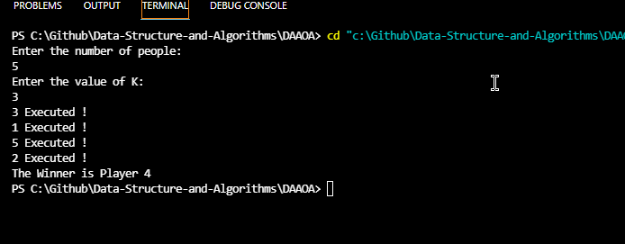

- Recursive Solution
Code:
#include <bits/stdc++.h>
using namespace std;

int jos(int n, int k)
{
if (n == 1)
return 0;
else
return (jos(n - 1, k) + k) % n;
}

int main()
{
int n, k;
cout << "Enter Number of People: " << endl;
cin >> n;
cout << "Enter Value of K: " << endl;
cin >> k;

cout << "Winner is : " << jos(n, k) << endl;
}

Output:
